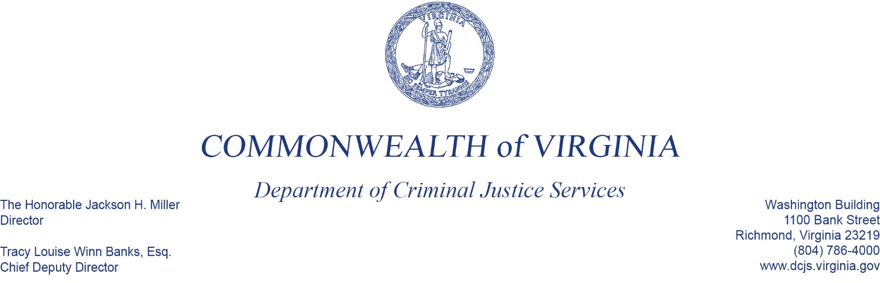
To: Criminal Justice Services Board Grants Committee
From: Kristina Vadas, Manager, Victims Services
Date: June 2, 2022
Re: Southside Center for Violence Prevention Discussion

Southside Center for Violence Prevention (SCVP) is a nonprofit sexual and domestic violence agency serving Southside Virginia, which includes Farmville, Prince Edward County, and several surrounding localities (agency-identified primary service areas include: Amelia, Buckingham, Cumberland, Lunenburg, Mecklenburg, Nottoway, & Prince Edward).

During the March 3rd Grants Committee meeting, Tom Fitzpatrick, former Programs and Services Division Director, informed you about concerns with SCVP, and as you know, the CJSB voted to rescind SCVP’s American Rescue Plan Act (ARPA) grant award during the March 17th meeting.

DCJS has had ongoing, long-term concerns about this agency for many years; however, substantial programmatic and financial concerns were documented following a DCJS onsite visit in 2020.

Since the 2020 site visit, DCJS staff have provided extensive assistance and support to SCVP. We have also collaborated with other state partners, including the Virginia Department of Social Services and the Virginia Sexual & Domestic Violence Action Alliance, in attempts to sustain and bolster this agency.

Of note recently, SCVP has not been adequately staffed since November 2021. Beginning in September 2021, all but one staff person (the executive director) resigned from the organization. Subsequently, a chain reaction of events occurred that made DCJS staff very concerned for wellness and safety of victims served by SCVP.

Earlier this year, DCJS staff initiated a Corrective Action Plan (CAP) process. SCVP did respond to the CAP; however, their responses were inadequate, and corrective actions were not satisfactorily completed.

Additionally, DCJS staff made the decision to put a hold or “freeze” on all other funding to SCVP due to a specific event reported to us (and confirmed by SCVP) in which there was potential harm to a victim. This funding hold was effective as of March 29, 2022.

It is important to note that SCVP has been unable to meet the grant goals and objectives that they outlined in their original Victims Services Grant Program (VSGP) application to us, which of course, is what the CJSB based its initial grant award approval on. For reference, their original VSGP 24-month award totaled $818,305, but to date for SFY 2022, they have requested reimbursement of only $216,780.59. In their grant application, they estimated that they would serve 75-100 victims per year, but to date this fiscal year, they have reported serving a total of 50 victims.

Concerns about this agency persist. DCJS staff have identified continued programmatic issues, and both by SCVP’s own account, and accounts of other service providers in the community, SCVP is not adequately serving victims. There continues to be a lack of adherence to protocols and practices that ensures that victims are appropriately served.

As a result, DCJS staff propose ending all funding to this organization by terminating their Victims Services Grant Program award. We have determined that there is a risk to victims in the SCVP community, and there is a risk to DCJS as the State Administering Agency of Victims of Crime Act (VOCA) funding. It is not in the agency’s best interest to continue funding this organization.

---------------------------------------------------------------------------------------------------------------------

Additional supporting information for termination of funding:
- SCVP does not currently meet the VOCA eligibility criteria as cited in the VOCA Rule and VSGP grant application guidelines:
  - Eligible applicants must demonstrate a record of providing effective direct services to crime victims. In accordance with the federal VOCA Rule, a program has demonstrated a record of effective services when, for example, it demonstrates the support and approval of its direct services by the community, its history of providing direct services in a cost-effective manner, and the breadth or depth of financial support from sources other than the Crime Victims Fund.
  - VOCA eligible agencies must promote, within the community being served, a coordination of public and private efforts to serve and aid crime victims, and provide program information to the majority of agencies that assist with victims of crime in the service delivery area.
- As the State Administering Agency of VOCA funds, DCJS and the CJSB have sole discretion to terminate a subaward for lack of compliance (per our DOJ Office for Victims of Crime Program Manager, Frederick Rogers).

If funding is terminated:
- DCJS staff will work with SCVP to complete any necessary close-out processes.
- DCJS will reimburse SCVP for any grant-related expenses through March 29, 2022, the date of the hold on funds.
- DCJS staff will work with our state partners, the Virginia Department of Social Services and the Virginia Sexual & Domestic Violence Action Alliance, on determining other/additional options for victim services in SCVP’s area.
- DCJS will work to mitigate the impact of this decision on victims of crime, to the extent that we can.

